**SMART LIVING ROOM**

# **Problem statement**: Design and suggest automation implementations for a room containing an AC, fan, lights, windows, electrical appliances, routers, and a fire alert system.

**I**

**NTRODUCTION**

**I**

**NTRODUCTION**

**INTRODUCTION**:

The concept of home automation has been around since the late 1970s though with the advancement in technology and services, people’s expectations of what a home should be or how the services should be provided for and accessed at home continues to change. Smart Home describes a residence that has appliances, lighting, heating, air conditioning, televisions, computers, entertainment (audio and video systems), security, and camera systems that can communicate with one another and can be controlled remotely by a time schedule, from any room in the home, as well as remotely from any location in the world by phone or internet facility. Today, mobile phones are used as clocks, calendars or controllers instead of just for making and receiving calls. With the help of the internet, a mobile device can be used to implement a smart home by controlling devices and getting alerts. The Internet of Things (IoT) is a system of inter-related computing devices, mechanical and digital machines, objects, animals or people that are provided with unique identifiers and the ability to transfer data over a network without requiring human to human or human to computer interaction, (Wadhwa & Puri, 2016). Now and over time efficient, convenient, and safe ways to access homes will be provided for. Irrespective of the change in user expectations, advancement of technology, or change of time, the role of a home automation system has remained the same. Throughout the late 1990s and early 2000s, smart technologies has emerged, with gadgets and devices becoming more and more common, and more affordable.

# **Components used**:

1. Laptop and mobile
2. Resistor
3. Flame Sensor
4. Buzzer
5. Nodemcu ESP8226 board
6. Motor driven fan
7. Led bulb
8. Blink app

# **Hardware used**:

**Flame sensor**: A flame-sensor is one [kind of detector](https://www.elprocus.com/emf-detector-circuit-working-types-and-its-applications/) which is mainly designed for detecting as well as responding to the occurrence of a fire or flame. The flame detection response can depend on its fitting. It includes an [alarm system](https://www.elprocus.com/fire-alarm-circuit-using-thermistor/), a natural gas line, propane & a fire suppression system. This sensor is used in [industrial boilers](https://www.elprocus.com/what-is-steam-boiler-working-principle-types-of-steam-boilers/). The main function of this is to give authentication whether the boiler is properly working or not. The response of these sensors is faster as well as more accurate compare with a heat/smoke detector because of its mechanism while detecting the flame.

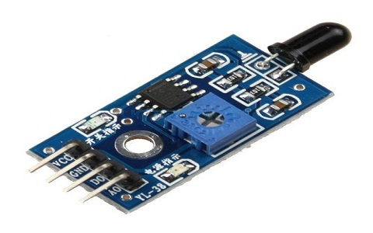

Flame sensor

**Nodemcu ESP8266 board**: It can be used as a standalone device, or as a UART to Wi-Fi adaptor to allow other microcontrollers to connect to a Wi-Fi network. For example, you can connect an ESP8266 to an Arduino to add Wi-Fi capabilities to your Arduino board. The most practical application is using it as a standalone device.

With the ESP8266, you can control inputs and outputs as you would do with an Arduino, but with Wi-Fi capabilities. This means you can bring your projects online, which is great for home automation and internet of things applications.

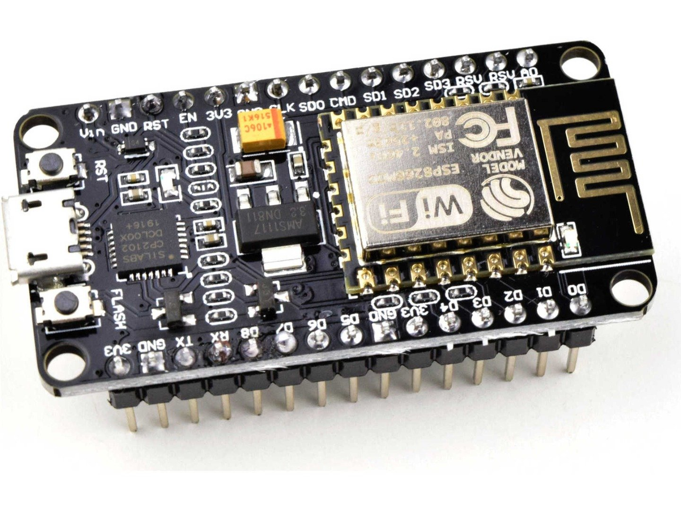

Nodemcu ESP8266 board

# Block diagram

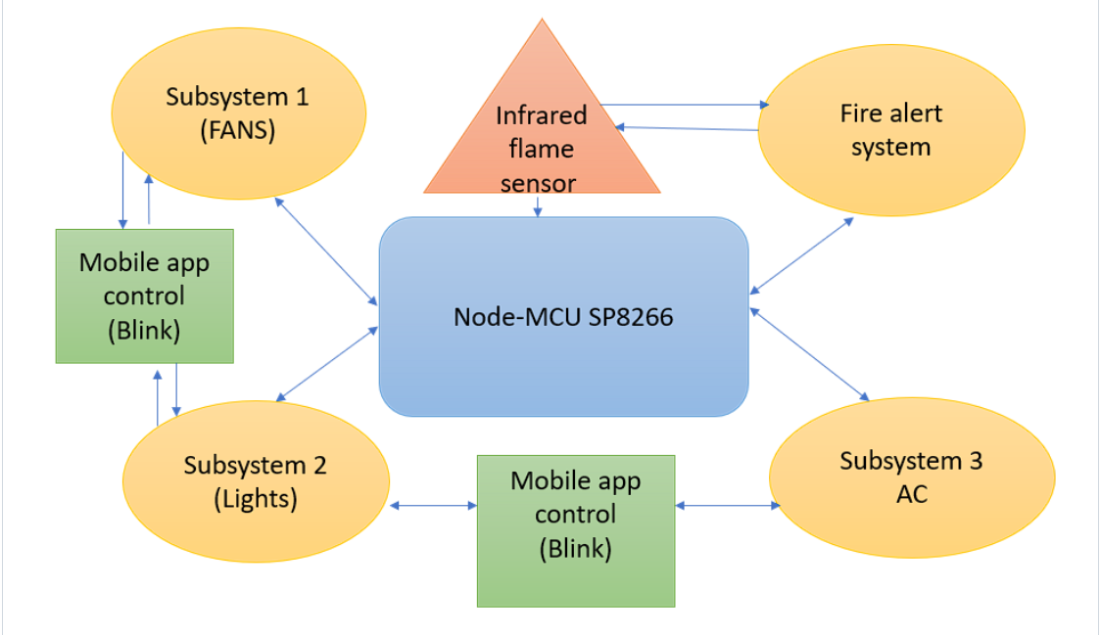

##### **Execution approach**:

The below data flow diagram works where the microcontrollerbased system automatically controls the room lights. The aim is to turn on or off the lights in a room and fans by using blynk. The implementation is done using NodeMCU and LED. The second part is that using a flame sensor the fire alert system is designed and buzzer is setup along with LED's. Since the job of the circuit is to turn on the light and fans or off them using the blynk app. Hence, this acts as an Automatic Room using electronic devices like laptops and mobile phones.

# Data flow diagram:

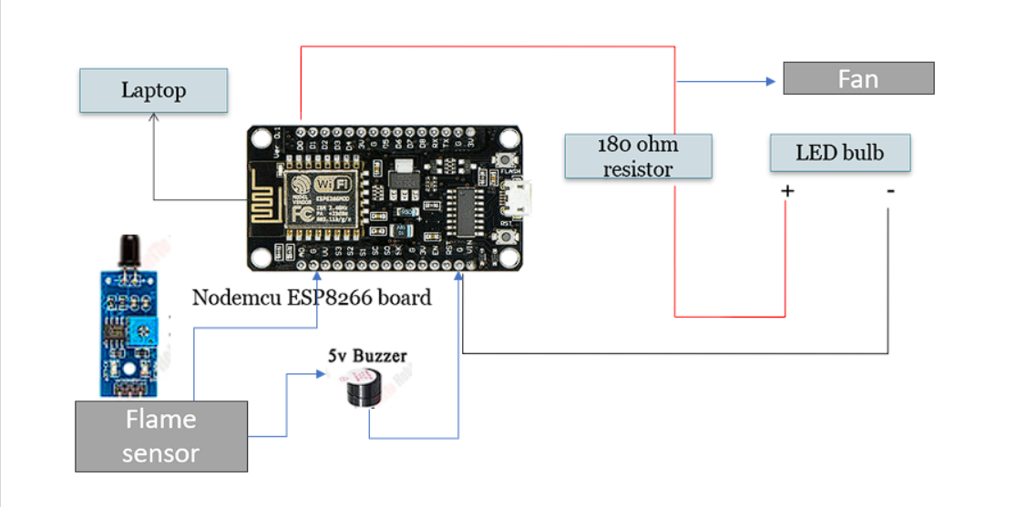

###### Special features/advantages of the design:

Will automatically turn on or off the lights, fans in a room by operating with blink app, Fire alert system provided to detect fire which causes serious complications, Home automation is provided smart ways using Nodemcu which is easy and efficient to use with less cost and also using a single Node MCU we can control the lights, fans in a room by operating with blink app and also detect fire by using infrared flame sensor smartly. Use of Nodemcu ESP8266: Built-in Wi-Fi Connectivity, Cost Effectiveness, Compact Size, Open-Source Hardware and Software, Low Power Consumption, Support for Various Programming Languages and Cloud Integration. The digital World we are living in allows us to use different technologies to automatically perform certain tasks. Such automation is very useful in certain areas like energy consumption, reducing human efforts, improving standard of living. Reduction in energy consumption, Increased comfort and convenience through automated actions, Enhanced safety through fire alert integration, Improved productivity by automating routine tasks and Potential cost savings on energy bills and appliance maintenance.

**Result:** The proposed plan of real implementation and all the goals required of the smart room was observed and tested.

**CONCLUSION:**

Smart room is an advance extension of commercial room to make life very comport for its residence. In the paper, design of smart room was discussed along with a block diagram and all hardware.